|  |
| --- |
| **For Immediate Release**: May 27, 2020  **Contact:** Kathryn Habecker  Indiana United Ways: [kathryn.habecker@iuw.org](mailto:kathryn.habecker@iuw.org), 317-399-5844 |

 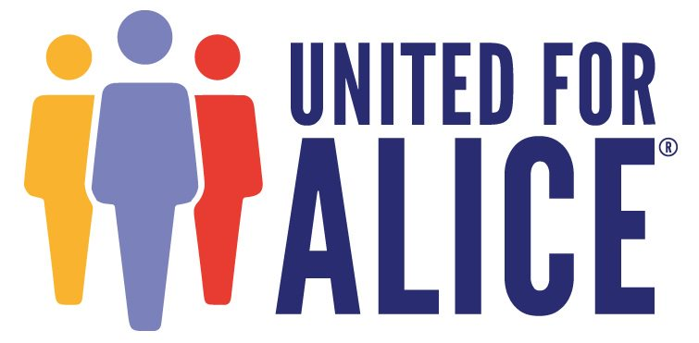

**COVID-19 Hit as Record Number of ALICE Families  
Were Priced Out of Survival**

***ALICEReport: A crisis in the making with a 52% increase in Indiana’s ALICE households over 10 years, fueled by high-priced basics and stagnant wages***

To read a copy of the report and find county-by-county and town-level data on the size and demographics of ALICE as well as the community conditions and costs faced by ALICE households, visit [www.UnitedForALICE.org/Indiana](http://www.UnitedForALICE.org/Indiana).

**Indianapolis, INDIANA** — When COVID-19 hit, nearly 950,000 Indianahouseholds were already one emergency away from financial ruin — a 10-year record high — setting the stage for the unprecedented economic impact of the crisis, according to the state’s latest ALICE (Asset Limited, Income Constrained, Employed) report, released today by Indiana United Ways in partnership with United Way of Central Indiana and United For ALICE.

Over the last decade, Indiana’s low-income families systematically lost buying power and financial stability as the high cost of essentials outpaced wages, driving the number of ALICE households to continue to rise.

“We’ve known that our economy was increasingly reliant on these families we call ALICE, who are often one emergency away from financial crises,” said Indiana United Ways President & CEO Maureen Noe. “COVID-19 became that one universal emergency. ALICE families are facing the greatest health and financial risks today, as they are the workers who do not have health insurance, have no paid sick days, and whose children rely on daily meals at school.”

In 2018, of Indiana’s 2.6 million households, more than 610,000 were ALICE; a record number were unable to afford the basics for survival, despite working. That is in addition to the nearly 330,000 families that were living in poverty. While wages for ALICE workers remained largely stagnant, the cost of six key essentials grew on average 3.4 percent annually over the past decade, in contrast to a rate of inflation of 1.8 percent. The report shows ALICE households were locked out of the boom economy and unable to establish savings due to meager pay raises and inconsistent job hours, schedules, and benefits. As a result, ALICE households accounted for 24 percent of Indiana’s households in 2018, up from 16 percent in 2007. In contrast, poverty levels remained largely flat at about 13 percent.

“No matter how hard ALICE families worked, the gap between their wages and the cost of basics just kept widening,” said Noe. “These already fragile ALICE households are now facing an even deeper financial hole due to the state of emergency created by COVID-19.”

ALICE in Indiana: A Financial Hardship Study shows that in 2018, the cost of survival ranged annually from $21,228 for a single adult, to $24,024 for a senior citizen and $60,756 for a family of four with an infant and a preschooler. Putting this in perspective, the median hourly wage for cashiers, the most common occupation in Indiana,was $9.68, or $19,360 per year — less than all these budgets.

This mismatch between wages and costs is revealed by a new measurement debuting in this report, called the ALICE Essentials Index. This Index chronicles how the cost of housing, childcare, food, transportation, health care and a smartphone plan rose at nearly twice the rate of inflation, as measured by the Consumer Price Index. The result is that in 2018, two parents working full time needed to earn $15.19 an hour in order to afford the Household Survival Budget for a family of four. That’s up from a wage of $10.56 an hour affording that budget in 2007. During the same period, the number of low-wage jobs grew by 106 percent, accounting for nearly one-third of all jobs in Indiana by 2018.

“The ALICE Essentials Index shows that, through no fault of their own, ALICE families have been priced out of economic stability, setting the stage for the scope of this crisis,” said United for ALICE National Director Stephanie Hoopes, Ph.D. “Using the Consumer Price Index alone to measure inflation provides an incomplete picture of the cost of living, severely underestimating the mounting financial pressures on ALICE families.”

Noe said the report’s findings should be put in play immediately to identify state and local supports that address the unique challenges the COVID-19 pandemic has inflicted on ALICE families as businesses and schools remain closed indefinitely.

The report calls for stakeholders across all sectors to use its findings to remove obstacles to financial stability, identify gaps in community resources and build data-driven solutions to help ALICE families achieve economic stability, bolstering the state’s economy overall.

The ALICE Report for Indiana was co-sponsored by Indiana United Ways and the United Way of Central Indiana and is a project of United For ALICE, a grassroots movement of some 650 United Ways in 21 states, corporations and foundations, all using the same methodology to document financial need. ALICE Reports provide county-by-county and town-level data, and analysis of how many households are struggling, including the obstacles ALICE households face on the road to financial independence.

For more information or to find data about ALICE in local communities, visit [www.UnitedForALICE.org/Indiana](http://www.UnitedForALICE.org/Indiana) or contact Kathryn Habecker, [kathryn.habecker@iuw.org](mailto:kathryn.habecker@iuw.org), 317-399-5844.

**About Indiana United Ways**

Indiana United Ways is the state association for United Ways in Indiana that supports thriving United Ways through capacity building, shared services, and partnering. Visit iuw.org to learn more.

**About United Way of Central Indiana**  
United Way of Central Indiana is a community of donors, advocates, volunteers, and partners who fight for the health, education, and financial stability of every person in every community. United Way invites all members of our community to LIVE UNITED by giving, advocating and volunteering to improve lives in Central Indiana. Visit [uwci.org](https://uwci.org/) to learn more.

**About United For ALICE**

United For ALICE is a driver of innovation, shining a light on the challenges ALICE (Asset Limited, Income Constrained, Employed) households face and finding collaborative solutions. Through a standardized methodology that assesses the cost of living in every county, this project provides a comprehensive measure of financial hardship across the U.S. Equipped with this data, ALICE partners convene, advocate, and innovate in their local communities to highlight the issues faced by ALICE households and to generate solutions that promote financial stability. The grassroots movement represents United Ways, corporations, nonprofits and foundations in Arkansas, Connecticut, Florida, Hawai‘i, Idaho, Illinois, Indiana, Iowa, Louisiana, Maryland, Michigan, New Jersey, New York, Ohio, Oregon, Pennsylvania, Tennessee, Texas, Virginia, Washington and Wisconsin; we are United For ALICE. For more information, visit: UnitedForALICE.org.

###